

**Mikisew Cree First Nation**

**Community Based Monitoring**

**- Key Program Activities and Protocol   
 Descriptions**

**Water Quality**

The Mikisew Cree First Nation Community Based Monitoring (CBM) program samples water chemistry and Indigenous Knowledge Indicators weekly (during the open water season) at 7 sites:

1. Water intake;
2. Quatre Fourches at Lake Mamawi;
3. Quatre Fourches towards Peace River;
4. Des Rochers River;
5. Lake Athabasca;
6. Cree Creek at Lake Mamawi; and,
7. Embarras River Mouth

At each site information is collected on water temperature, conductivity, dissolved oxygen, pH, salinity, ORP (*ORP to be removed in 2017 and Chlorophyl A added)* as well as Indigenous Indicators of water health. Additionally, weather descriptions are logged and a geographical position is taken. All data is collected on a custom app based database system containing internal quality control features. Monitoring staff employ a YSI Pro Plus meter, and a Analite NEP 160 Turbidity meter or a WTW Multi 3410 Turbidity meter.

Results are reported to the community to demonstrate changes to water quality over time and employ both western science and Indigenous Knowledge indicators to this end. Example program results are presented below in figures 1-3.

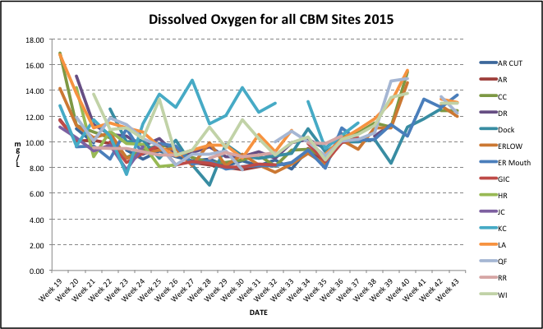

Figure 1. Dissolved Oxygen at all CBM sites for 2015 (includes ACFN sites).

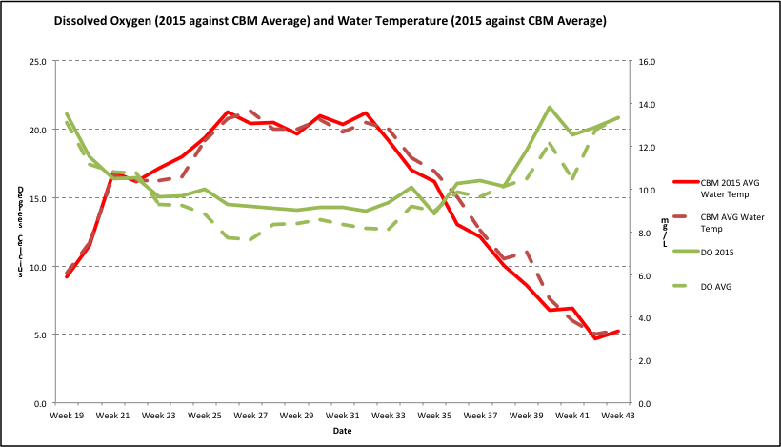

Figure 2. Dissolved oxygen levels and temperature at all CBM sites averaged in 2015 against long-term average

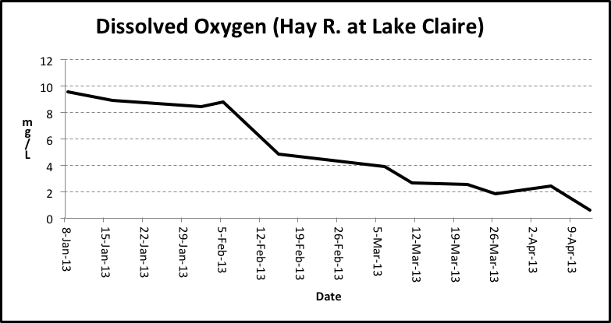

Figure 3. Dissolved Oxygen Levels Decline to Zero at Hay River Site (winter of 2013).

Laboratory collections

• 3 times a year (Spring, summer, and fall)

• When resources exist are also collect in the winter

• Maintain consistent sites with overlap for QC/QA between ACFN

Principle collection sites

• Water intake Both

• Des Rochers MCFN

• Hay River MCFN

• Quatre Fourches MCFN

• Embarrass River ACFN

• Athabasca River ACFN

• Jackfish ACFN

Reference sites

• Flett Creek ACFN

• Pine Channel MCFN

At each laboratory water collection site water chemistry is taken (DO, pH, turbidity and temperature). Lab used is Taiga labs, with outsourcing to Flett Labs for Hg.

Data Analysis and Reporting

* Water quality index developed to provide either a green, yellow, or red indicator per site for overall water quality. Based on three variables:
  + How many parameters exceed CCME guidelines at one site;
  + How often they exceed guidelines per site; and,
  + The amplitude with which they vary from the guideline.
* Tied to environmental risk assessment

*When a site indicates concern (yellow or red) further effort can be given to look at more specifics around what is causing the concerns (i.e. specific contaminants) and further sampling can occur in that region.*

Lab Sampling Parameters (per site)

* Routine
* pH, Conductivity, Alkalinity
* All Anions
* Total Nitrate (NO2) + Nitrate (NO3)
* All Cations
* Hardness
* Nutrients
* Nitrogen: Total, Dissolved
* Turbidity
* TSS, TDS
* Ammonia
* Phosphorus: Total, Dissolved, Ortho
* Carbon: Total and Dissolved
* Metals
  + Aluminum (Al)
  + Arsenic (As)
  + Barium (Ba)
  + Beryllium (Be)
  + Cadmium (Cd)
  + Chromium (Cr) speciated
  + Copper (Cu)
  + Cyanide (CN)
  + Iron (Fe)
  + Lead (Pb)
  + Lithium (Li)
  + Manganese (Mn)
  + Mercury (Hg) speciated
  + Molybdenum (Mo)
  + Nickel (Ni)
  + Selenium (Se)
  + Silver (Ag)
  + Vanadium (V)
  + Zinc (Zn)
* Totals only for metals (unless further effort warranted)
* Hexane Extractable Materials (O&G)

**Water Quantity**

Rationale

Low water affects the ability of Mikisew Cree First Nation (MCFN) members to reach traditional use areas. Figures 4 and 5 demonstrate the extreme loss of access possible in the PAD at flow rates lower than 400 m3/s.

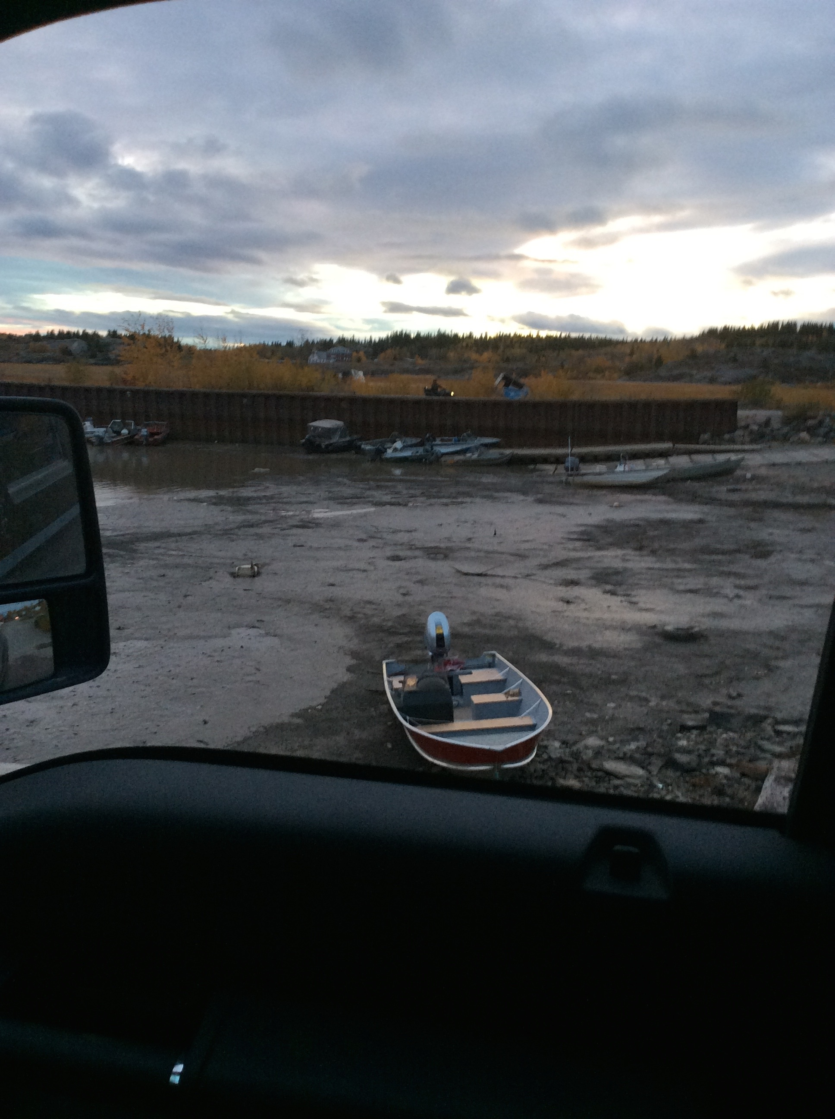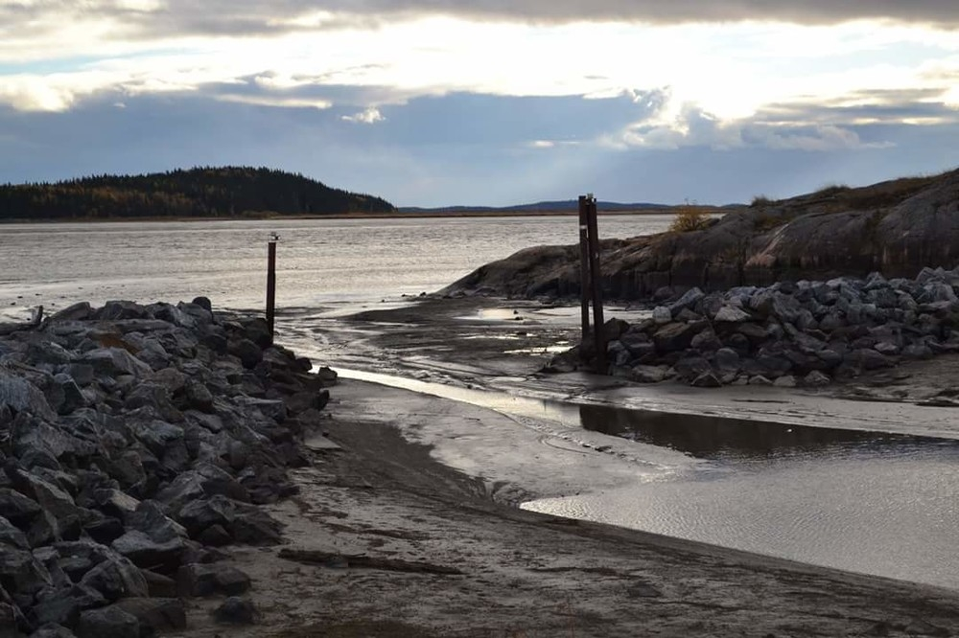

Figures 4 & 5. No water in both Fort Chipewyan harbours.

The above photos were taken on September 27th, 2015 when Athabasca River flows were estimated at 368 m3/s. Navigation was essentially at zero, as no MCFN member could leave the harbor to fish, hunt, gather, pray, or otherwise exercise Treaty and Aboriginal rights.

Monitoring Design

Key questions were framed to guide the program in addressing a community identified decline in water levels. The initial design of the CBM program was intended to shed light on a number of key questions related to the decline in water levels experienced in the PAD over the previous two decades:

1. At which territory access points does water level correlate well with the discharge of the Athabasca River at Fort McMurray? Is there a basis to infer that the correlations observed are causal? Where is there little or no correlation?

2. How do water levels in the PAD vary in relation to each other at critical access sites distributed around the territory? Are there recognizable patterns in stage behaviour given the number and range of factors that can influence water level?

3. Is a threshold apparent in Athabasca River discharge, as measured at the hydrometric station near Fort McMurray that corresponds to thresholds of use at critical access pinch points distributed around the territory? If so, in which parts of the PAD is it directly applicable?

4. Is a value of 400 m3/s for the Aboriginal Extreme Flow (AXF) reasonable given the behavior of water levels as documented in the CBM program?

Depth Protocols

MCFN CBM staff collect weekly depth readings at 6 sites (Figure 6), and further data is collected by ACFN technicians. All data is shared.

Staff take ten depth readings, evenly distributed across each cross-section. The information enables a reasonable resolution of the variability of the bed and provides options for analysis of regional correlations.

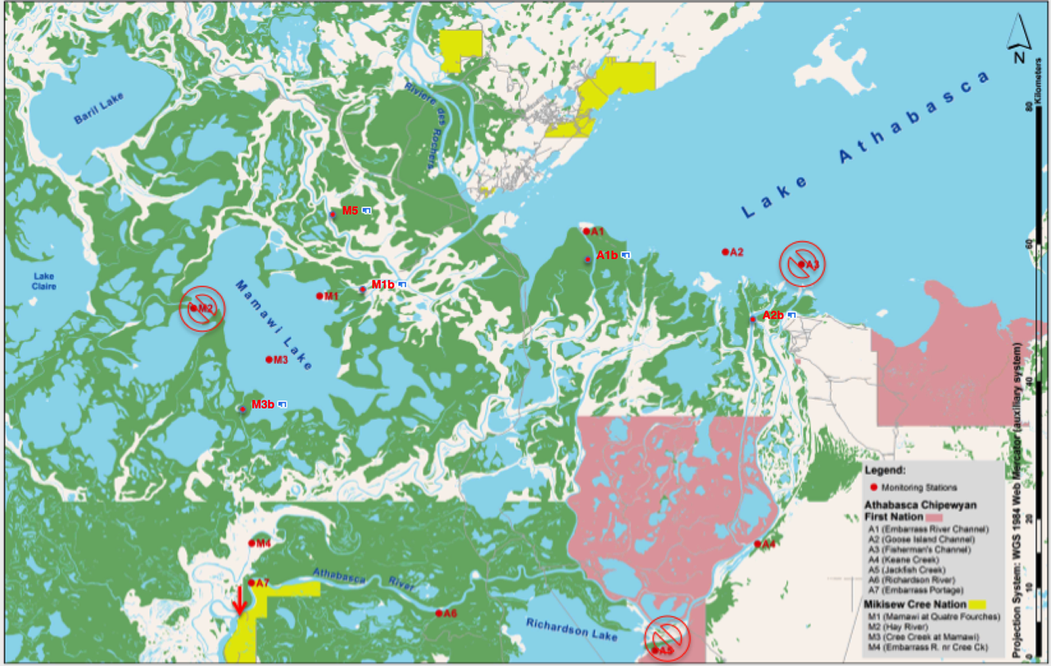

Figure 6. CBM Depth Monitoring Sites (ACFN sites included).

Data has been used to validate the concept of the Aboriginal Extreme Flow (Figure 7), and to constructively challenge aspects of Alberta’s Surface Water Quantity Management Framework, most notably the assumptions in their Aboriginal Navigation Index or ANI. In Figure 7, as flow rates approach 400 m3/s depth reaches 122 cm or the Aboriginal Extreme flow; - the MCFN policy describing navigational loss.

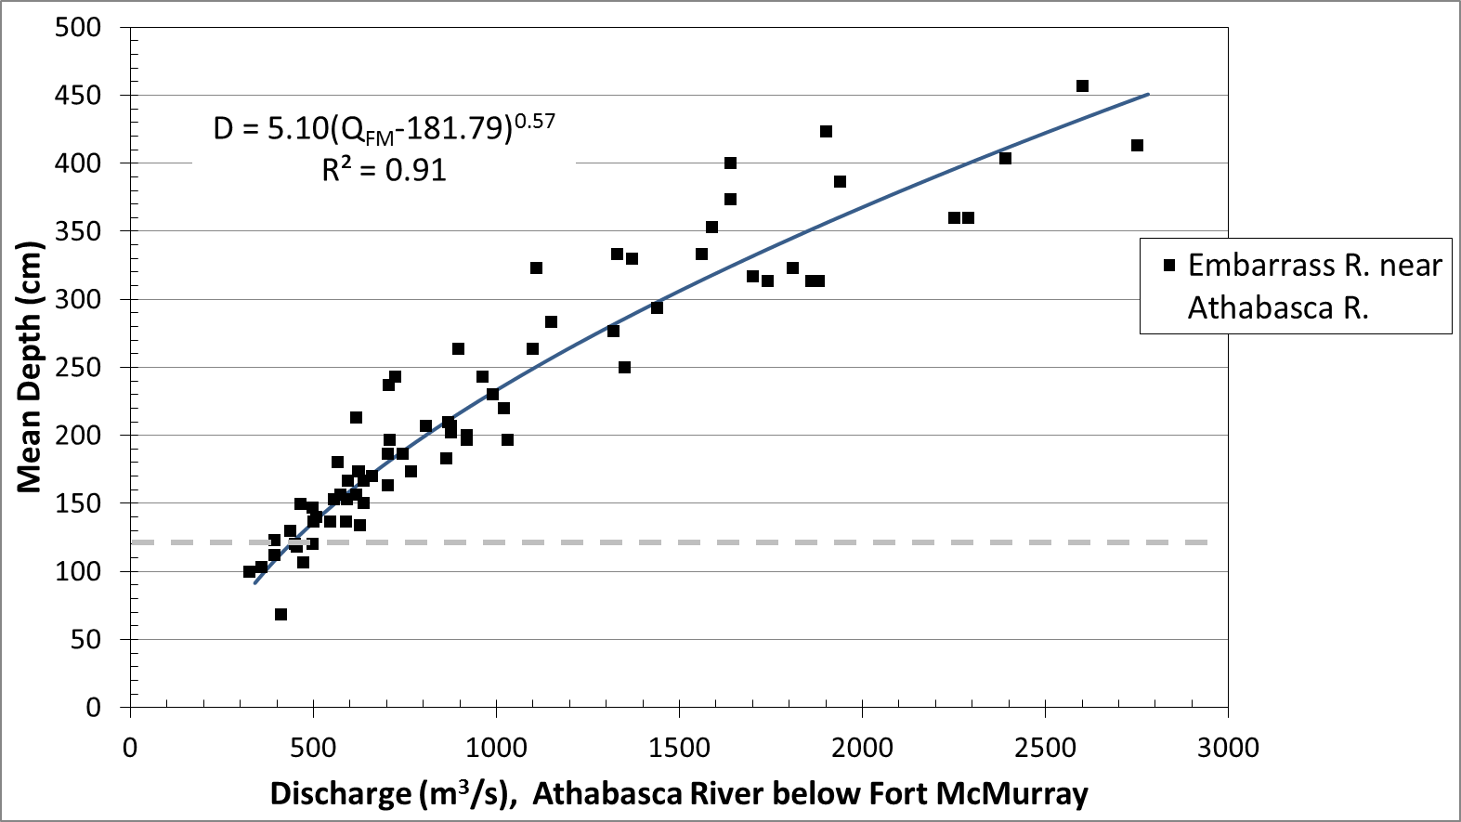

Figure 7. Preliminary power function relating depth at Embarras Low Point (CBM site M4) to the discharge of the Athabasca River below Fort McMurray.

**Winter Sampling**

Winter travel conditions are changing as a result of hydro development (release of water in winter which floods ice), oil sands development (withdrawl of water on the Athabasca River), and climate change (warmer winters/changes in precipitation amount and timing).

CBM staff take weekly winter samples at 6 sites:

1. Water Intake
2. Lake Athabasca
3. Quatre Fourches
4. Lake Mamawi
5. Hay River
6. Peace River (at Moose Island)

At each site snow depth, ice depth, Indigenous Knowledge Indicators of ice quality and water chemistry are taken. Data is used to track changing conditions related to climate change and development and also provide valuable information to the community about winter travel safety. Data is shared with community (Figure 8).

A goal of the monitoring program is to expand efforts to assist in the prediction of potential ecological flow releases from B.C operating dams to create ice jams and subsequent overland flooding to restore inland lake productivity.

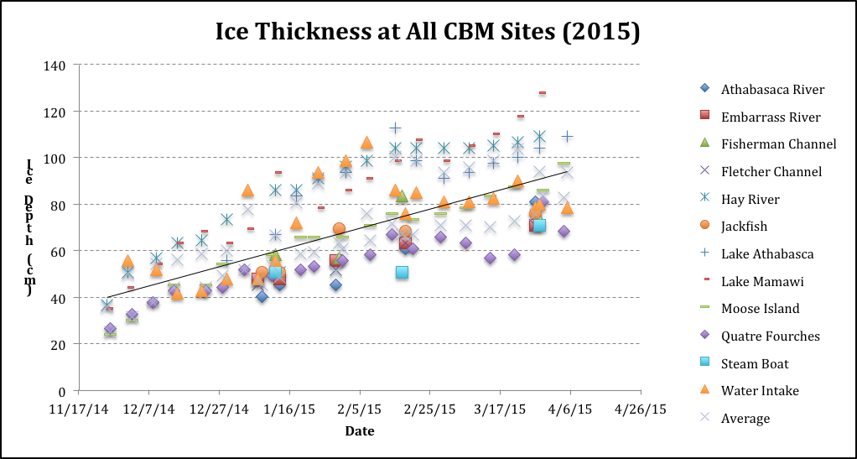

Figure 8. Ice thickness at combined CBM sites (ACFN and MCFN) for 2015.

**Wild Foods of Concern**

The CBM acts as an intake of wild foods of concern, and have freezers, shipping logistics and laboratories to undertake wild food veterinarian analysis, as well as contaminant analysis. We have participated in biomonitoring studies for gull eggs, fish and prey fish, moose, otters, muskrats. A strong informal partnership exists with Parks Canada to co-ordinate this research. To date the CBM program has examined 2 large fish kills, one seagull die off, and extensive research on muskrats, otters, ducks and moose.

**Data Management**

The Mikisew Cree have developed (with partners ACFN, Kwusen and software developers Affinity Bridge) a sophisticated Android App based data collection (Figure 9) and management system. The CBM database system links into the MCFN’s wider Land Use Planning and regulatory management software, known as the Community Knowledge Keeper.

The database offers custom, quality controlled field data collection sheets, safe data storage, and online reporting and data manipulation tools. The database is currently in operation for water depth, water quality, and winter sampling.

Efforts are underway with the Government of Alberta to develop a adaptation measures as a result of low water on the Athabasca River, known as the Navigational Hazard App. This will allow the CBM program to more widely collect information on navigation challenges on the Athabasca River and Peace Athabasca Delta, with the goal of having better data to advance adaptation measures for safe navigation.

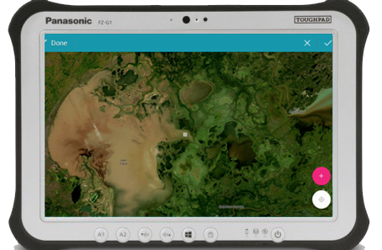

Figure 9. MCFN Database Field App.

**Other Relevant Research Capabilities**

* **Core sampling:** Equipment (Uwitech corer) and training to take core samples with demonstrated successful age stratification
* **Sediment sampling:** Equipment (ponar and eckman) and training to take sediment samples
* **Polycyclic Aromatic Hydrocarbon sampling:** Equipment and training to install PMDs
* **Acoustic Sampling:** Training to install Acoustic Sampling Recorders and trail cameras
* **Flow sampling:** Training with Hatfield Consultants, and University of Waterloo to measure in-stream flow
* **Snow sampling:** Training in ECCC protocols and successful field campaigns in snow sampling for metals and PAHs
* **Biomonitoring:** Training and hunter/trapper kits to collect wildfood samples for analysis
* Experience in deploying PISCES water sampling equipment
* Training to deploy depth loggers and water chemistry sondes
* Muskrat counts, bison counts